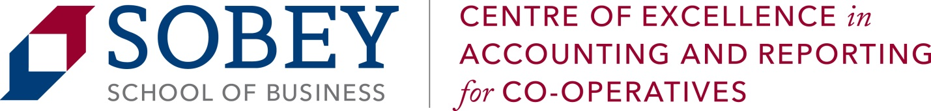
Journal of Co-operative Accounting and Reporting (JCAR)
Call for Papers
The Journal of Co-operative Accounting and Reporting (JCAR) is an open access, peer-reviewed and refereed international journal published by the Centre of Excellence in Accounting and Reporting for Co-operatives (CEARC) at the Sobey School of Business, Saint Mary’s University in Canada. The main objective of JCAR is to provide an intellectual platform for international scholars of co-operatives and social enterprises. JCAR aims to promote the study of accountancy and reporting for co-operatives, credit unions, and mutual organizations.
The journal publishes research papers focused on co-operatives, credit unions, and mutual organizations in all areas of accounting including:
- Theory and Practice | - Cost/Managerial Accounting
- Standards Performance | - Measurement and Analysis
- Education | - Financial Management
- Auditing Technology | - Innovation Management
- Information and Systems | - Tax Accounting
- Systems Management | - Public Responsibility and Ethics
- Behavioural Accounting  - Social and Environmental Reporting | - Knowledge Management

JCAR publishes original papers, review papers, conceptual framework, analytical and simulation models, case studies, empirical research, technical notes, and reviews of books and accounting standards. http://www.smu.ca/academics/sobey/faculty-and-research-jcarj.html. Please submit your papers to the editor: Daphne Rixon, PhD, FCPA, FCMA: daphne.rixon@smu.ca.
Submission due date: September 30, 2017

